Output of Non-Functional Testing Using Postman, REST Assured, and JMeter:

OUTPUT OF CODE ASSIGNMENT001

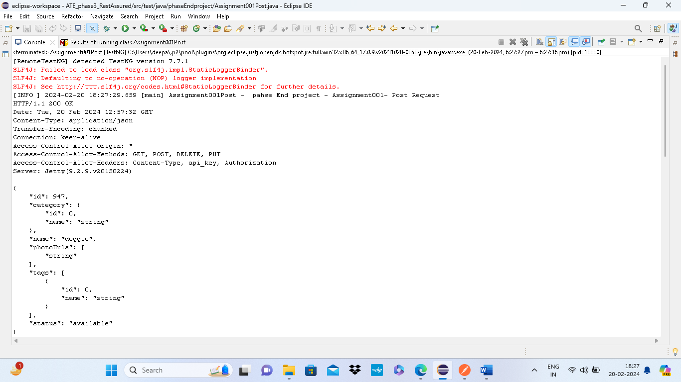

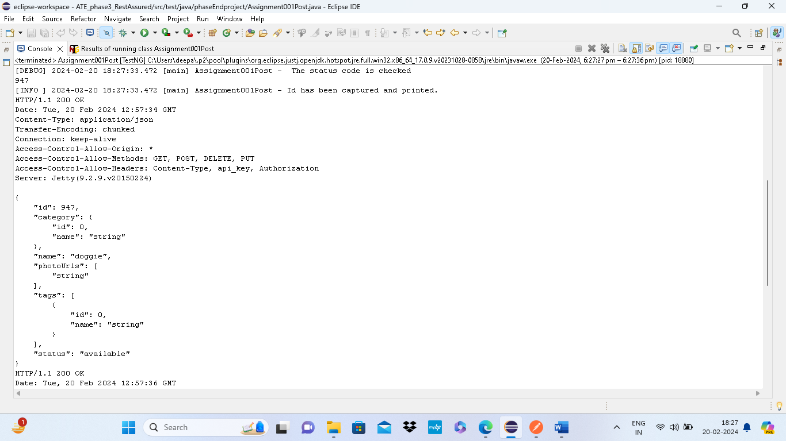

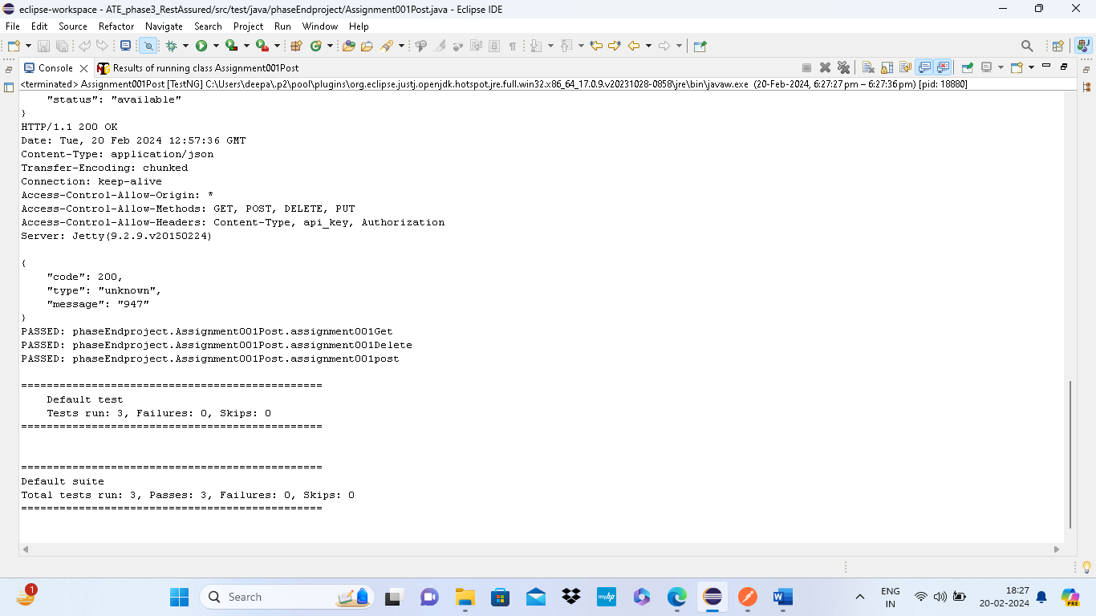

OUTPUT OF CODE ASSIGNMENT002:

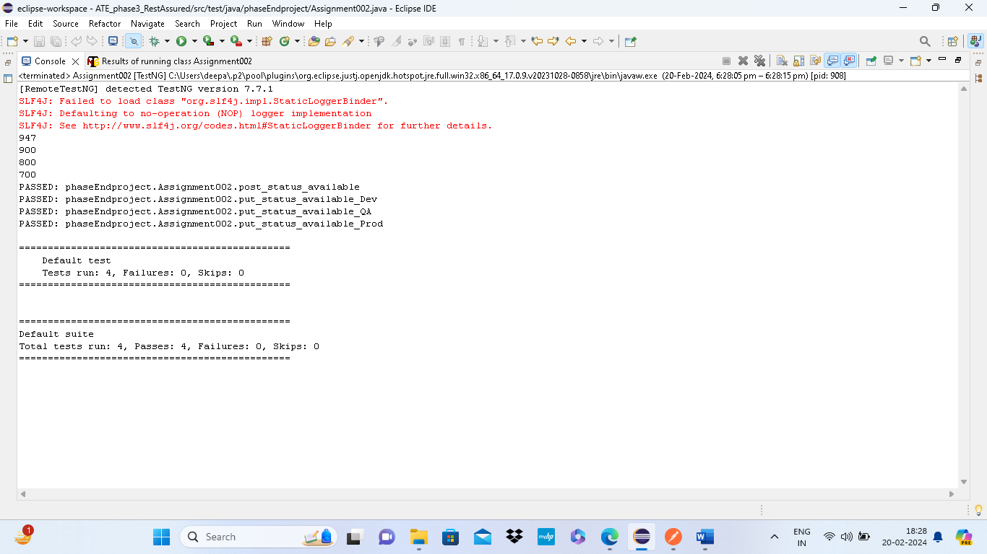

OUTPUT OF CODE ASSIGNMENT002003004005:

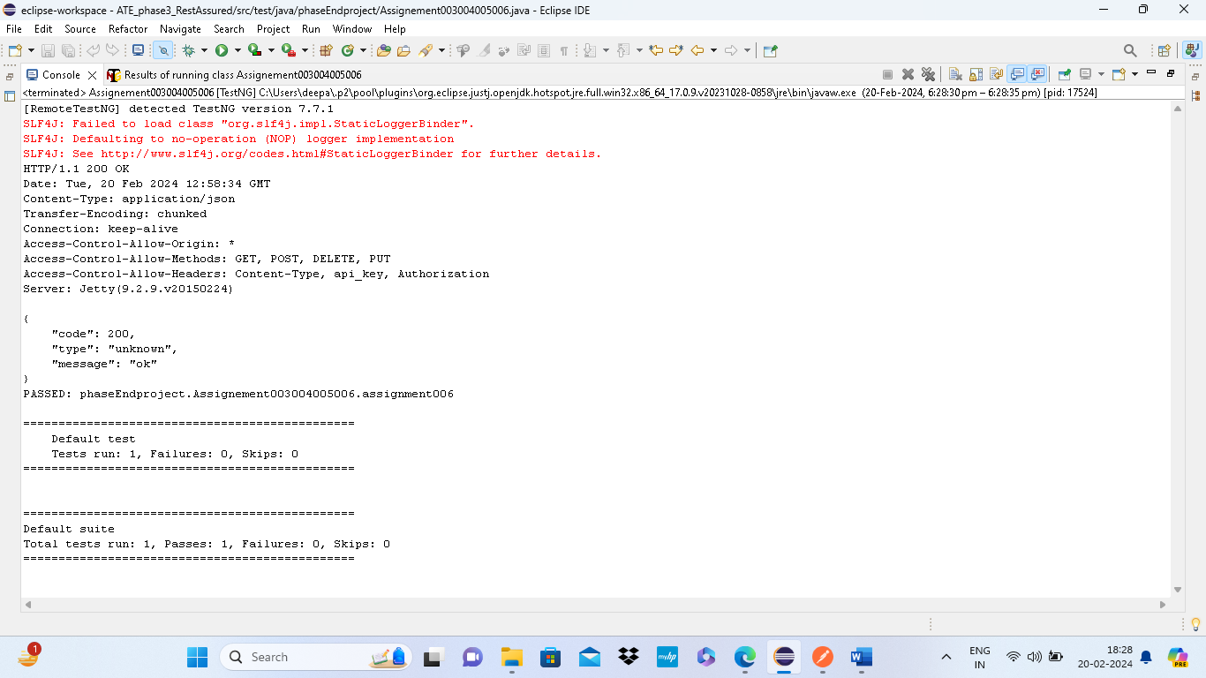

OUTPUT OF POSTMAN CODE PUT: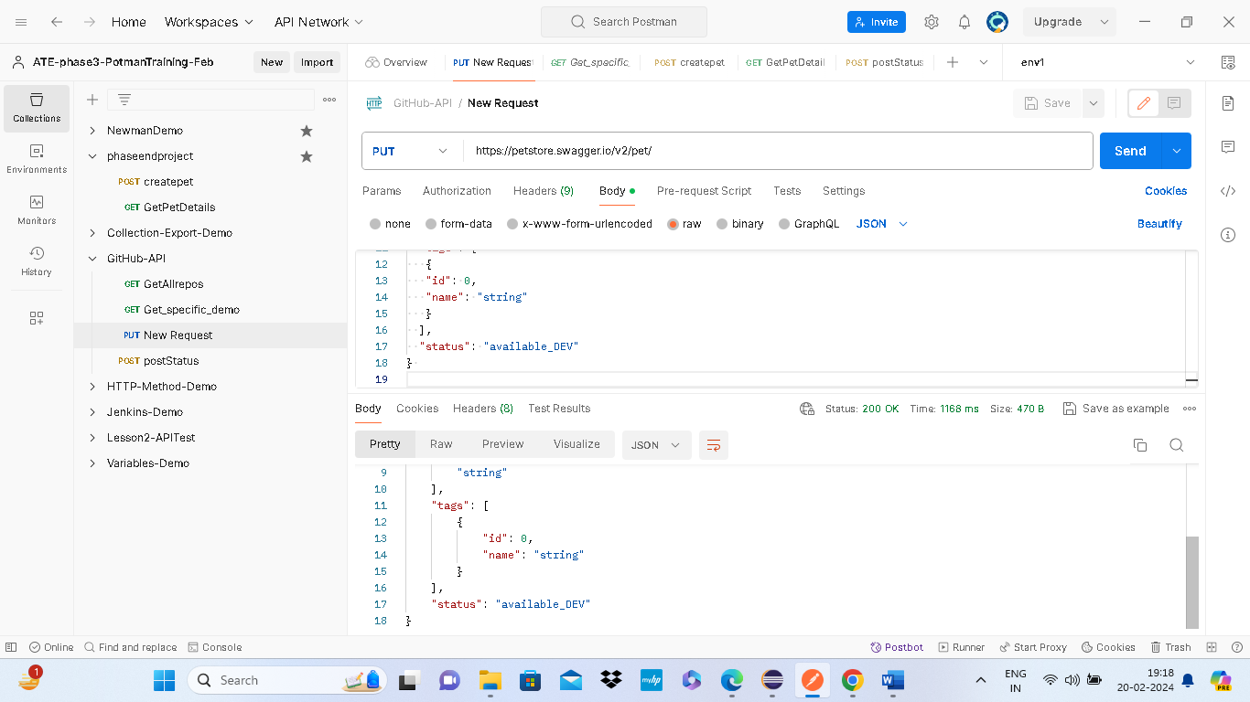

OUTPUT OF POSTMAN CODE POST:

